DATABASE MANAGEMENT SYSTEMS



Aldocaesar Nauval Zuhdi Sanny

L200154007

X class

MUHAMMADIYAH UNIVERSITY OF SURAKARTA

First is create role and grant.

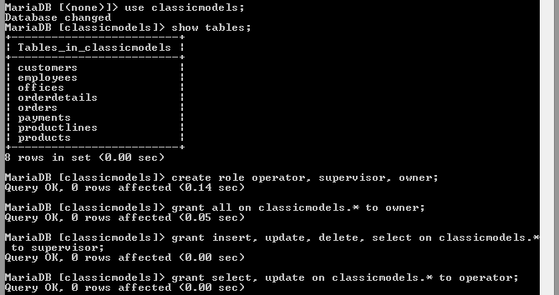

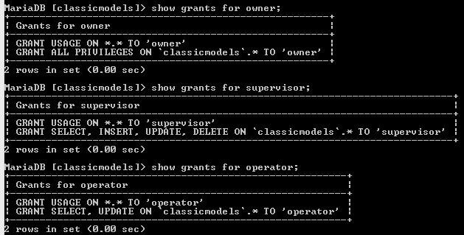

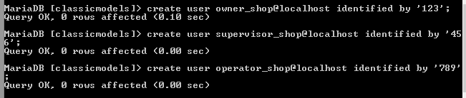

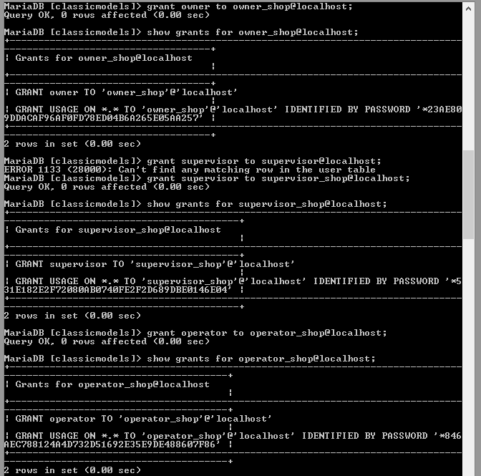

THE ROLE FOR OWNER, SUPERVISOR, and OPERATOR

1.OWNER

Role for owner is he can give all command while using database classicmodels. Owner can see the information from tables by selecting any tables, create new tables, update it, and also delete that tables. Insert any new goods that correlated with retail and also modifying data from that goods like their prices.



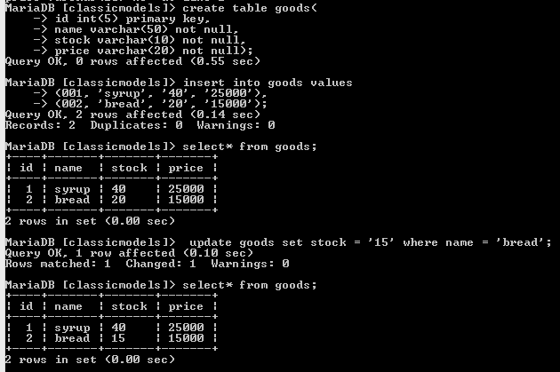

2.SUPERVISOR

Supervisor only can give 4 commands that allow him to view the goods with select command, put in new goods for retail with insert command, then if situation is change in the market he can change the price from goods with update command, and last he can delete a table or data.

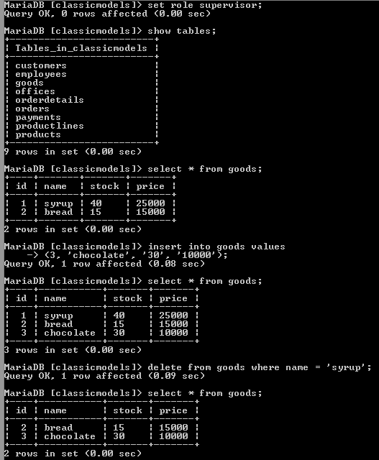

3.OPERATOR

Operator can update and select data from databases.